Google Analytics 4 Audit

1. Data tracking and tags 3
1.1 Tag Analysis 3
1.2 Google Tag Manager - Account Structure 4
2. Inspection of the Google Analytics 4 Account 5
2.1 Basic Preferences 5
2.1.1 Google Analytics Account Structure 5
2.1.2 Time zone, currency 6
2.1.3 Data stream 7
2.2 Enhanced measurement 8
2.2.1 Enhanced measurement 8
2.3 Configure tag settings 10
2.3.1 Internal traffic 10
2.3.2 Unwanted referrals 10
2.3.3 Cross-domain tracking 12
2.4 Data collection 13
2.4.1 Google Signals 13
2.4.2 User-ID and user-provided data collection 13
2.5 Consent settings 14
2.6 Data retention 16
2.6.1 User and event data retention 16
2.7 Data filters 17
2.7.1 Exclude internal traffic 17
2.8 Product links 17
2.8.1 Search Console links 17
2.8.2 Google Ads links 17
2.9 Attribution settings 18
2.9.1 Reporting attribution model 18
2.9.2 Channels that can receive credit 19
2.9.3 Key event lookback window 20
2.10 Data display 21
2.10.1 Events 21
2.10.2 Key Events 22
2.10.3 Custom definitions 22
3. Checking the sending of events 23
5. General Recommendations 24

1. Data tracking and tags

1.1 Tag Analysis
As you might see on the attached screenshots, there is no activity in Google Tag Manager (further GTM), neither tags nor variables were detected. This means that all information with application of scripts is transferred direct;y .
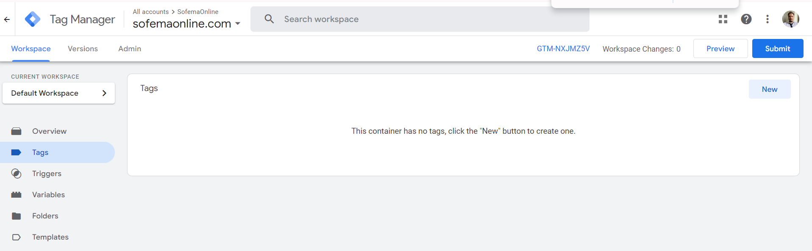
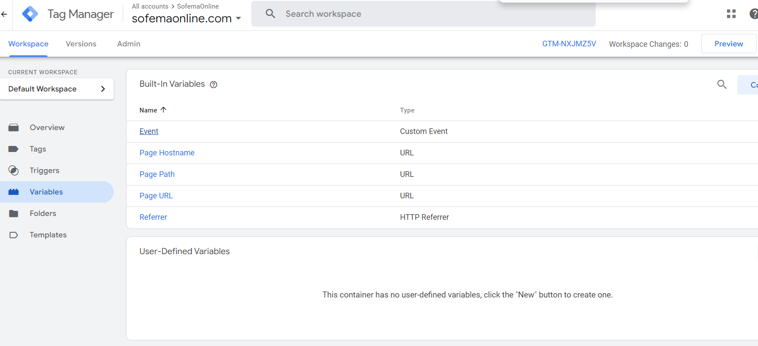

Caution! Without mitigating GTM of the data delivery from the web site to Google Analytics 4 (further GA4), there would be an option for building custom variables for the control of the data stream .

1.2 Google Tag Manager - Account Structure
Account - Sofema Online
Container- sofemaonline.com
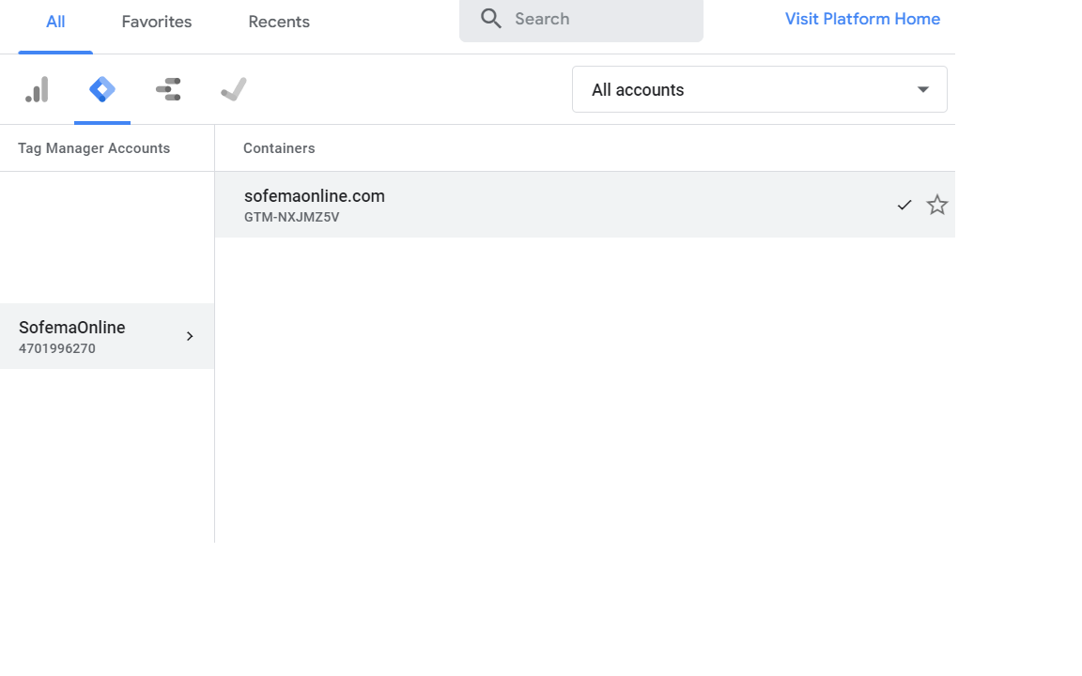
During the inspection, it was figured out that the basic events were not created for the further analysis in the GA4. Also, during the audit there was not found any container for the https://sassofia.com, as it can be witnessed on the previous screenshot. Therefore, I do strongly suggest adding a separate additional account to the mentioned site in order to keep the cross-domain statistics.

2. Inspection of the Google Analytics 4 Account

2.1 Basic Preferences

2.1.1 Google Analytics Account Structure
The well-structured Google Analytics account affects:
1) convenience and transparency of analytics;
2) effectiveness of goals tracking;
3) capability of data comparison;
4) quality of reports.

The process of checking:
Account - bentley
Property 1 - Sofema Aviation Services - GA4
Property 2 - SofemaOnline - GA4
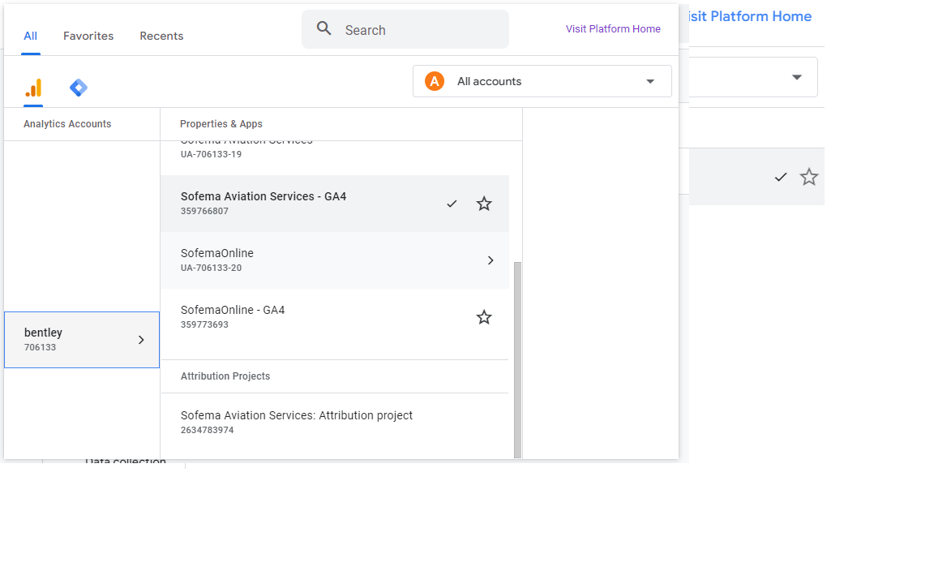

Conclusion: architecture is correct.

2.1.2 Time zone, currency
Time zone is the specific area which observes a uniform standard time in our case - to specify the attribution of the payment to a specific day. Currency is actually a standardized payment unit that depends on the region. In our case, currency is needed to ensure attribution of the currency source (it could have been skipped in case of mon-currency state).

Review process:
Property 1 - Sofema Aviation Services - GA4
Time zone - (GMT+03:00) Bulgaria Time Zone
Currency - Euro (€)
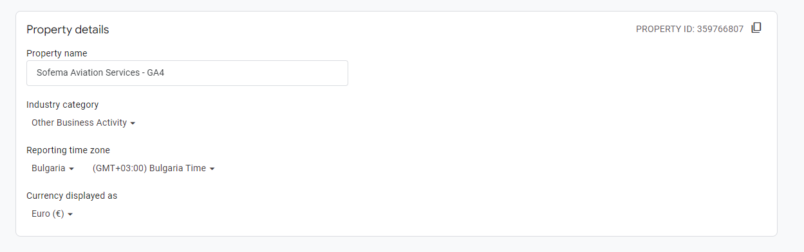
Property 2 - SofemaOnline - GA4
Time zone - (GMT+03:00) Bulgaria Time Zone
Currency - US dollar($)
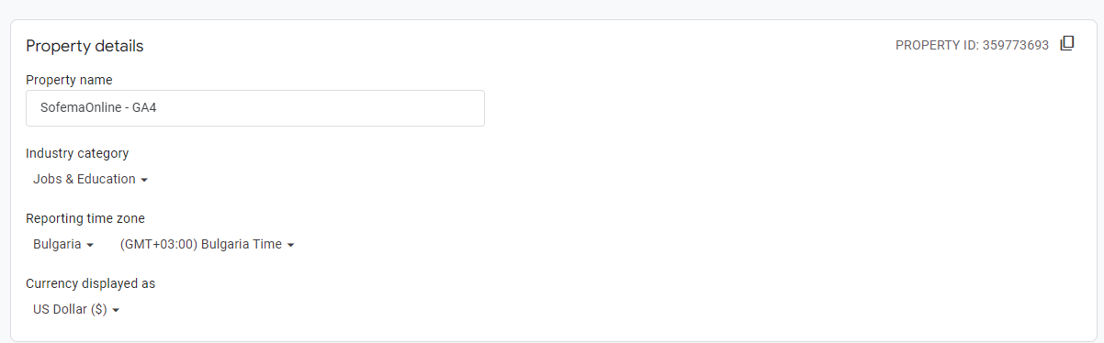
Conclusion:
(GMT+03:00) represents the Times zone of Bulgaria according to the mentioned time zone.
The USD and EUR currencies of the researched accounts represent the chosen currencies of both accounts.
Caution! Currency diversity might cause issues with the reports creation in terms of data comparison. Therefore, it would be preferred to convert all incoming traffic to a single currency for the further analysis.

2.1.3 Data stream
Data stream is the source of relevant data that originated either from a website or app. We recommend using no more than 3 data streams per resource: 1 - for user journey tracking throughout their interaction with the website, and each additional 1 for iOS and Android apps. I would explain the manner in which the system works with the following diagram:
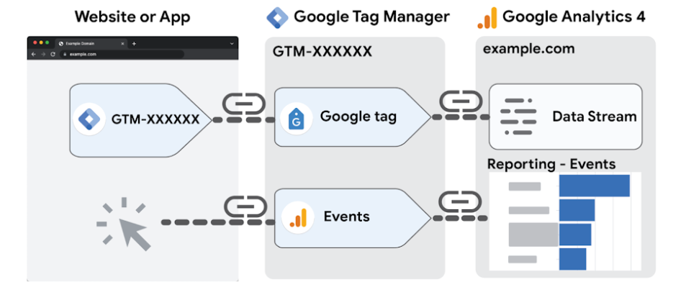
According to the diagram above, the difference of data stream with the simple events report is in the high customization and adaptation toward needs of the stakeholder. Data stream gets the data from GTM tags, adjusts them to the needed format for proper insights building and then accumulates them in the data stream. That is the reason why data streams are so important.
Review process:
Property 1 - Sofema Aviation Services - GA4
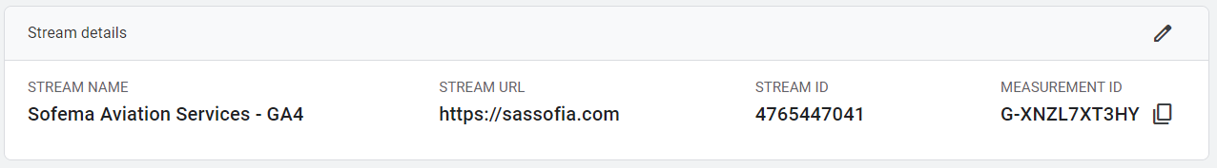

Property 2 - SofemaOnline - GA4
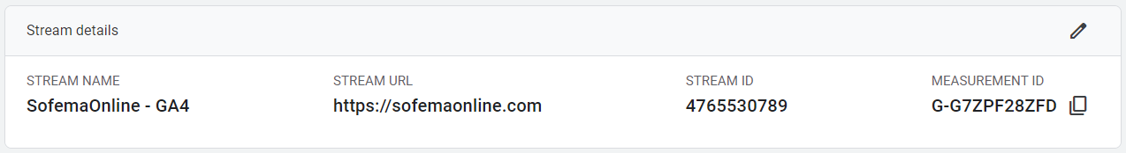
Conclusion: The data is gathered from both http://sofemaonline.com and http://sassofia.com . However, due to the unconfigured GTM, the data that are getting to the datastream are limited with the triggered events with all their issues and possible mistakes.

2.2 Enhanced measurement

2.2.1 Enhanced measurement
Enhanced Measurement is a function of the additional data gathering that includes clicks on external links, sending forms, viewing videos, etc. The mentioned function allows getting the additional details regarding the customers’ behavior both on website and in app.

Review process:
Property 1 - Sofema Aviation Services - GA4
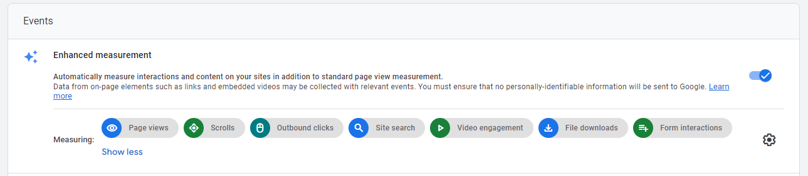
Property 2 - SofemaOnline - GA4
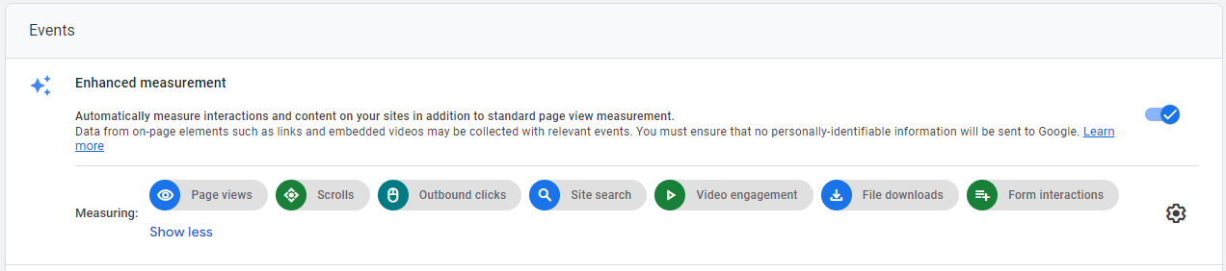
Conclusion: It is fair for both Properties that all data that can be tuned on for automated gathering are stored in the mentioned datastreams. Also, according to the following screenshot, page views are also active and cannot be turned off (implemented function of GA4). Due to the presence of the video information, search lines, and file downloading (in case of manuals and other useful information), we should consider keeping those options. However, the scrolls, clicks and forms tracking is rather an additional information and should be decided by your marketing team. Our recommendation is that in the case of your web architecture, those data would be rather artifacts (will bring no significant information without additional significant adjustments) and should be turned off.
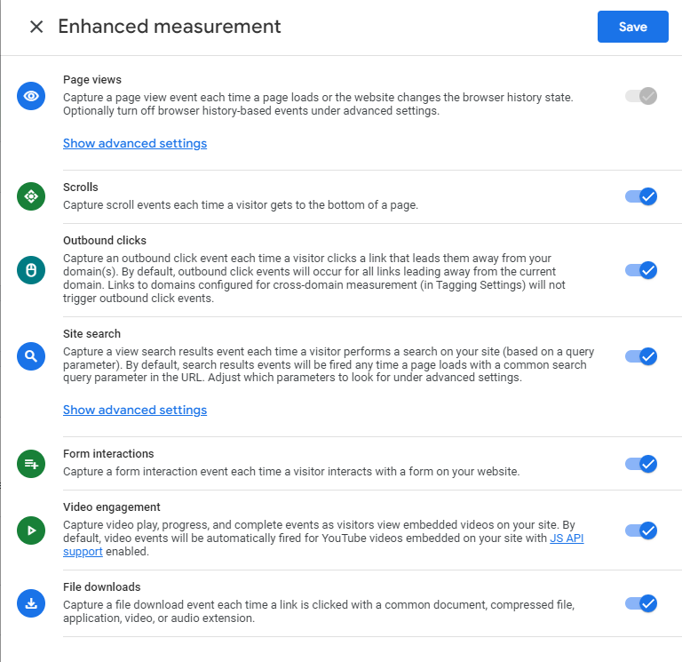
I would draw your attention to the following fact - scrolls currently show only the fact of scrolling instead of scroll depth (it can be witnessed by the value 90% in case of scrolling page more than 50%). If the marketing team is interested in gathering learning activity information, it would be extremely helpful to adjust scroll events for explaining the depth of scrolling performed by the user. In case of clicks - this is a trash category that incorporates all clicks on a page. For the sake of marketing analytics, the most important is Call-To-Actions (clicks on the specific buttons/links/actions). In order to collect that data, we would suggest creating a list of specific CTAs. Finally, forms tracking is also a category of discussion, while it provides incorrect data - if the form was sent, but then rejected by the system due to a filling error, this event will not detect the following ending of attempts of registering. Thus, tracking this event is related with adjustment of the tracking method.

2.3 Configure tag settings

2.3.1 Internal traffic
The internal traffic is not filtered and it might cause issues in future data analysis. On both Properties there was no filtering of the internal traffic, assuming that there is no differentiation of users on those that are working for the company and all others. Possible outcome of such issue is the possibility of Type 1 (false positive) and Type 2 (false negative) errors in data analyses. It means that the data would be interpreted in a wrong manner and will cause wrong judgments. To figure out the possible impact of the internal traffic the further research with application of SQl (BigQuery) is needed. Following screenshot is equal for both properties and represents the state-of-art on both resources.
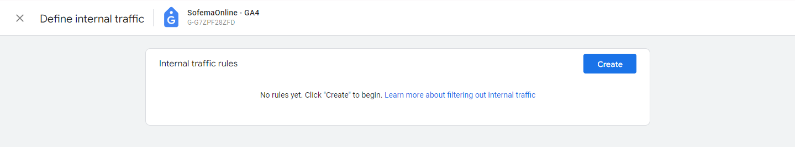

2.3.2 Unwanted referrals
"Unwanted referrals" - this is unwanted traffic that comes to your site from sources that are of no interest to you or are not relevant to your business. To ensure that your data includes only the conversions you want, you can define a set of conditions for domains whose traffic you don't want to be identified as conversions. This forms the list of unwanted referrals.

Review process:
According to the information provided in the account, for both properties it is true that there were no rules for filtering the unwanted traffic. This issue might have caused in a future the inaccurate understanding of sources and their conversion.
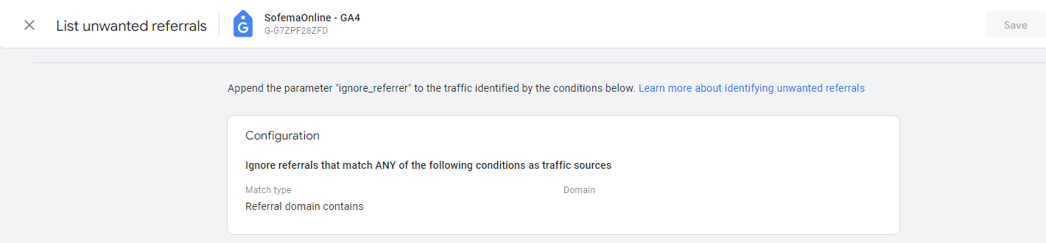
Conclusion: the list of Unwanted referrals was filled with the known paying systems. Accordingly, the following changes might be viewed for both Properties:
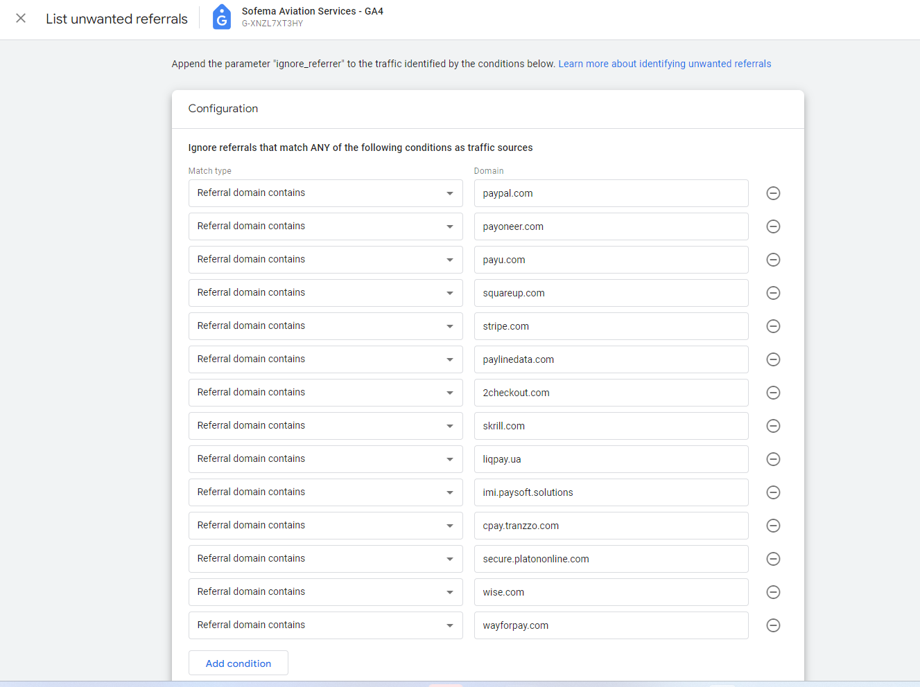

2.3.3 Cross-domain tracking
Cross-domain tracking - is a mechanism that allows tracking user behavior on several different domains or subdomains as one single mapping. This is important for sites that have a split architecture, such as when a user navigates from the main site to shopping or checkout pages located on other domains.

Review process:
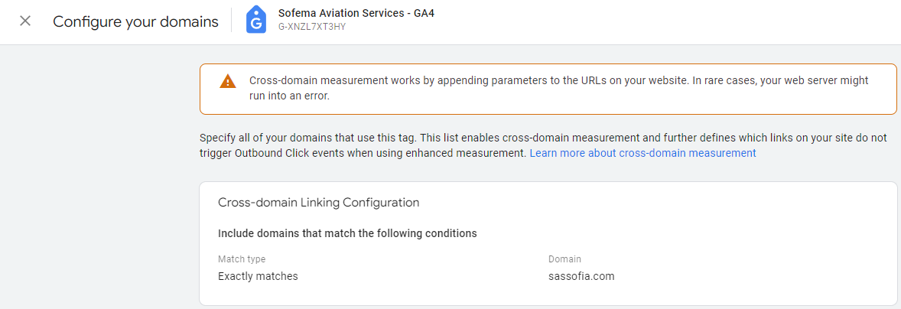
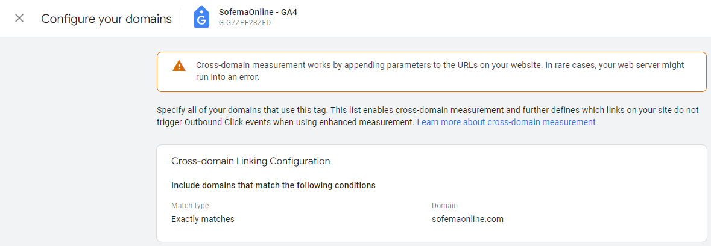
According to the provided above screenshots, we might see that there was already established cross-domain tracking for both Properties.
Conclusion: Cross-domain tracking is installed before the audit starts. However, due to the direct gathering of data, it actually doesn’t filter any cross-domain activity.

2.4 Data collection

2.4.1 Google Signals
Google Signals - is a feature of Google Analytics that enhances data analysis capabilities with personalized advertising reports. It combines data from different devices, such as computers, smartphones and tablets, to create a more complete picture of user behavior on your website.
Google Signals facilitates the analysis of dependencies between different devices that use the same Google Account, for example, when a user browses a website on a computer and then returns to it on a smartphone. This allows better understanding how users interact with content on different devices, helping optimization of website and marketing campaigns.
However, data from Google Signals may not always be completely accurate or representative due to the limited number of users who have enabled this feature.

Review process:
For both Properties Google Signals is turned on before the audit was conducted. The screenshot attached below shows it:
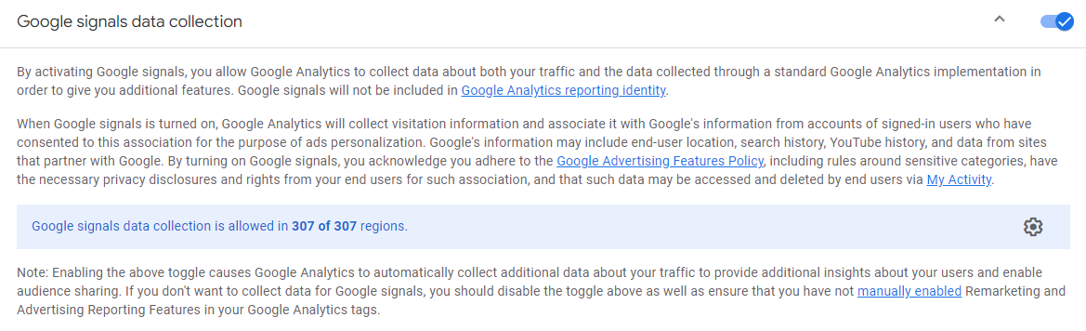
Conclusion: Google Signals is turned on for both Properties.

2.4.2 User-ID and user-provided data collection
User-ID and the collection of user-provided data allow us to collect more personal data about users and interact with them in a more personalized way. The impact of these methods is to collect data that allows you to understand users at a deeper level.
With Google Analytics data administrator or data editor rights, you can configure the collection of user-provided data to send your own data from website to Google Analytics, obtained with the consent of these users. The data you submit is then matched with other Google data in a privacy-friendly way to help improve measurement accuracy and enable Analytics.

Review process:
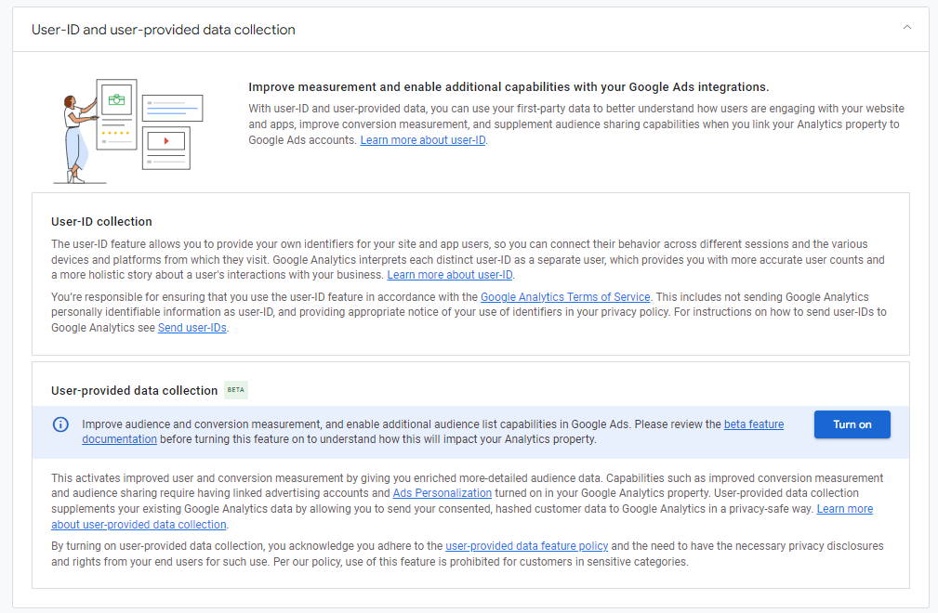
Conclusion: this feature is disabled. Caution!!! We do not advise you to rush with the connection, while .

2.5 Consent settings

Selling goods or providing services to EU citizens assumes preserving GDPR requirements. Therefore, it is needed to install a banner on the site that asks for consent to the collection of user data and configure tags so that they only work after receiving this consent.

Without the implementation of Consent Mode V2, advertising platforms such as Google Ads and Google Analytics 4 may not receive all needed data about new users from the EEA, which will significantly affect advertising strategies and data analysis performance.

Review process:
In the following screenshot it is shown how the web stream looks when Consent Mode V2 is not turned on.
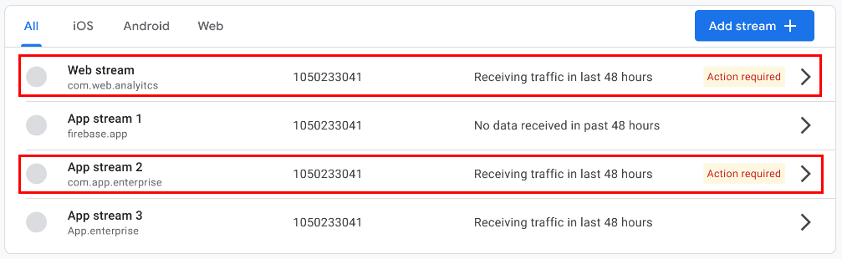
In case of Property 1 - Sofema Aviation Services - GA4 and Property 2 - SofemaOnline - GA4 (represented on the following screenshots), there is no need to turn on Consent Mode, because none of the data streams have an Action required label. Thus, Consent Mode is either already sending the required signals or has a low distribution of visitors based in the EEA.
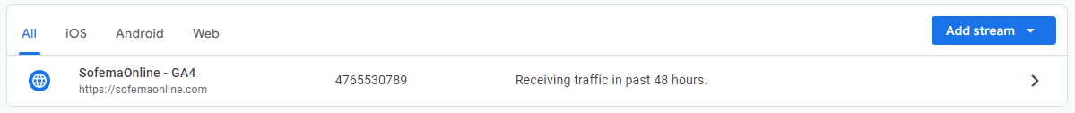
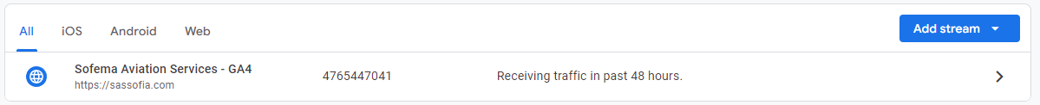
Conclusion: Currently, no need for changes.

2.6 Data retention

2.6.1 User and event data retention
User and event data retention affects the retention of user data and events related to their actions on your website or application. This means how long Google Analytics will keep this data before automatically deleting it. We suggest this time period to be maximal (14 months).

Review process:

For both Properties the Events data retention was placed on 2 months:
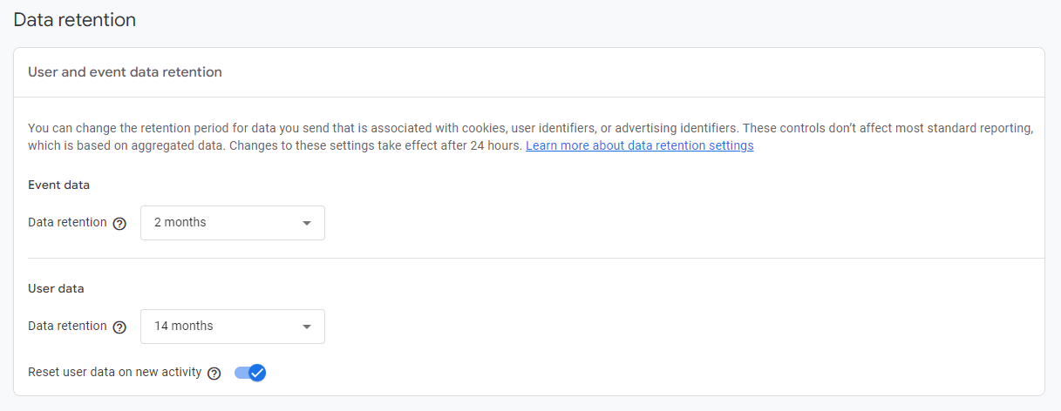
Thus, Events data retention for both Properties was changed to 14 months :
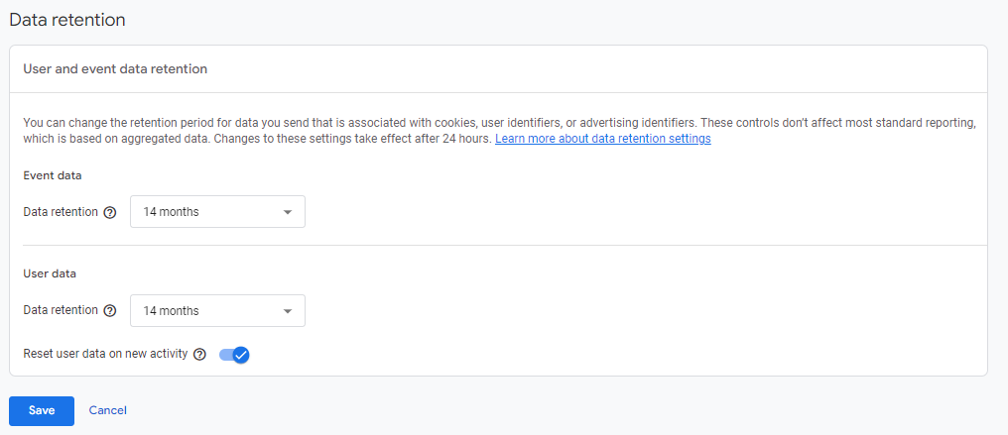

Conclusion: The maximum Events data retention period is selected- 14 months.

2.7 Data filters

2.7.1 Exclude internal traffic
The "Exclude internal traffic" filter affects the exclusion of traffic generated by employees or other internal sources that have access to your website or app.
Review process:
State = Inactive.
Before turning on this filter, it is needed to provide the list of IP addresses of employees, for making exclusion lists according to the part 1.3.1.

Conclusion: Part 1.3.1 should be performed first. Otherwise, this part is not applicable.

2.8 Product links

2.8.1 Search Console links
Communication with Search Console helps you optimize your website for better visibility in search engines and improve its performance in search Conclusions.

Review process:
Property 1 - Sofema Aviation Services - GA4
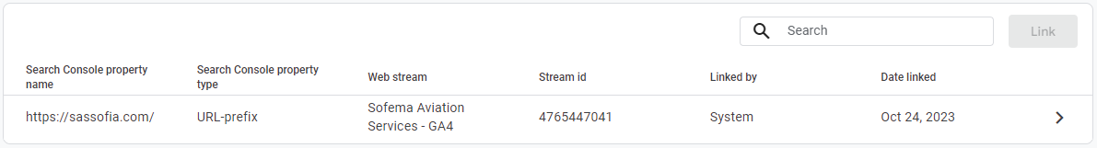
Property 2 - SofemaOnline
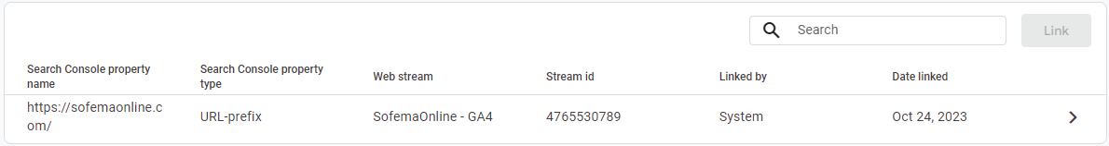
Conclusion: for both Properties Search Console Link is connected.

2.8.2 Google Ads links
Connecting to Google Ads allows you to see the full journey of users from interacting with your ad (for example, from clicking on ads) to taking conversion actions that you have set on your site or app (such as making purchases, using content, etc.).

Review process:
For both Properties no connection to Google Ads was found.
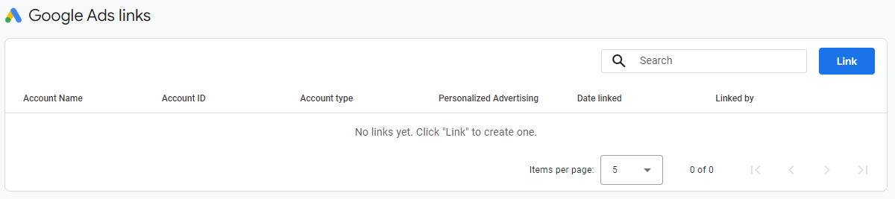
Conclusion: connection is absent.

Caution! Without connection to Google Ads the huge part of data that might have positively affected your decision-making process by providing the correct insights in performance of your business are missing. We recommend setting up this connection along with Google Big Query. This will provide an opportunity to work with raw data, as well as help save historical data for a longer period of time (in analytics, it is stored for a maximum of 14 months).

2.9 Attribution settings

2.9.1 Reporting attribution model
The reporting attribution model affects how conversion attribution is distributed between different marketing channels and customer touchpoints.
This is important for determining which channels and marketing activities contribute the most to conversions and how this is reflected in reports.

Review process:
For both Properties the correct (Data-driven) model is applied before the audit.
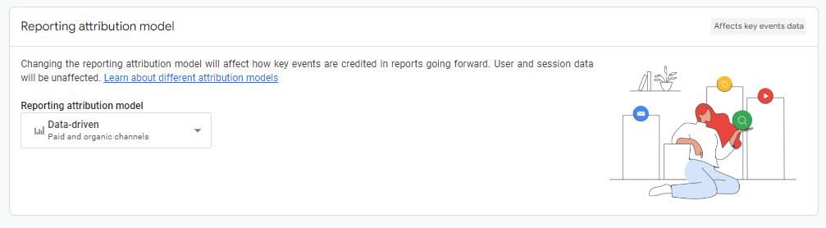
Conclusion: the correct data model is applied for both Properties - Data Driven

2.9.2 Channels that can receive credit
Channels that can receive credit impacts the selection of marketing channels receiving value for attracting conversions. This is important for apportioning credit and determining the contribution of each channel in the vast ecosystem of marketing efforts.

Review process:
Due to the lack of connection mentioned in 2.8.2. with Google Ads, there is no option for turning on Channels that can receive credit.
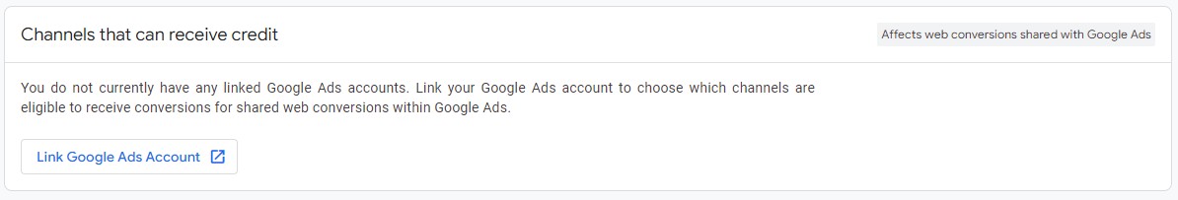
Conclusion: Previously mentioned in 2.8.2 adjustment of Google Ads should be turned on in order to have the option of changing channels that can receive credit.

2.9.3 Key event lookback window
Key event lookback window affects how far back in time the analytical system will consider certain key events when analyzing user behavior. This is important for determining the impact of previous actions on specific Conclusions or conversions.

Review process:
For both properties the same settings are applied. On the screenshot below, it is visible that Acquisition key events and All other key events are placed on the maximum value, which is the expected pattern.
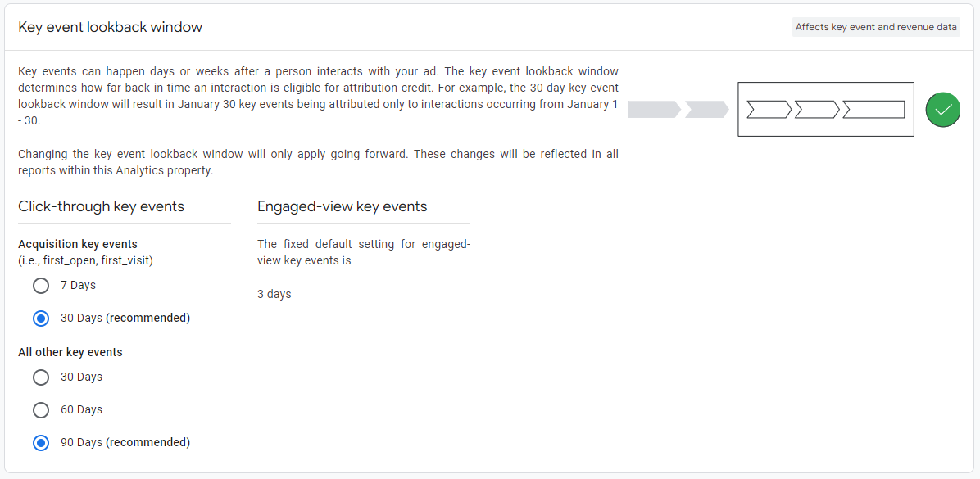
Conclusion: all settings are done correctly before the audit starts and no need for adjustments.

2.10 Data display

2.10.1 Events
Stored events:
Property 1 - Sofema Aviation Services - GA4
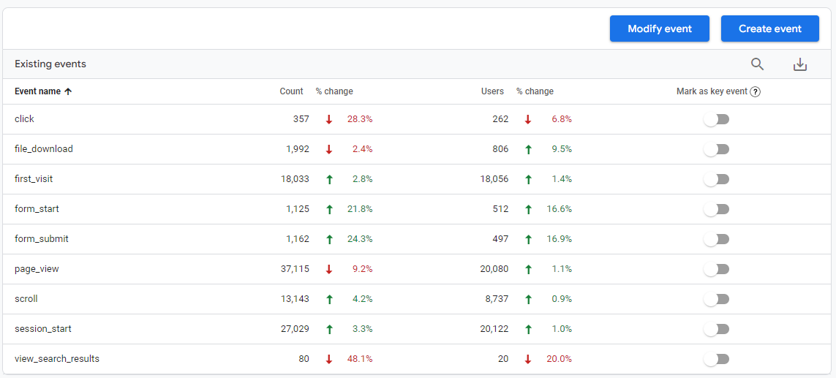
Property 2 - SofemaOnline - GA4
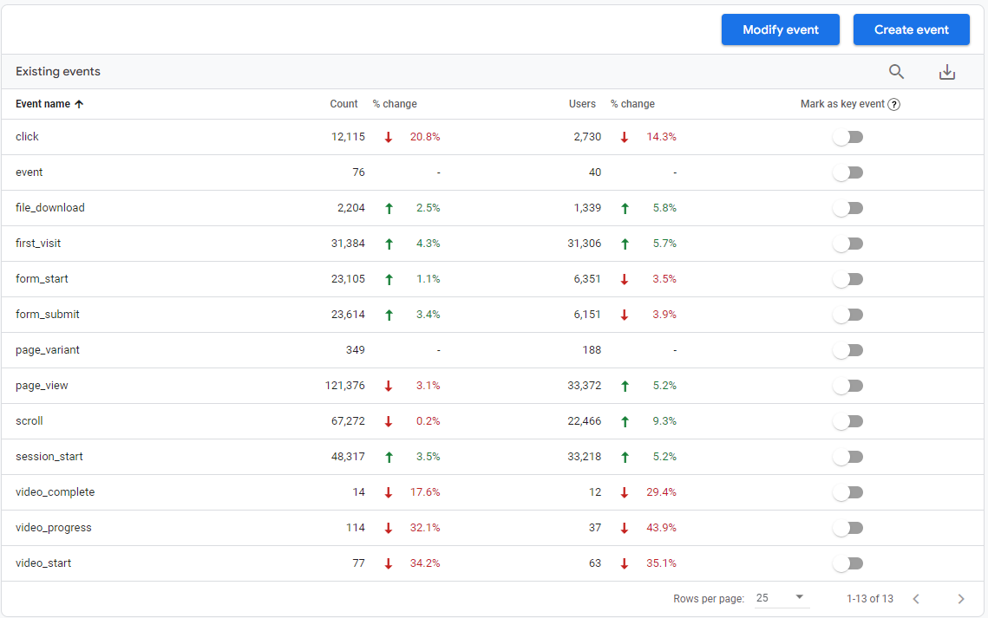

2.10.2 Key Events
A key event is an event that measures an action that's particularly important to the success of your business. When someone triggers the event by performing the action, the key event is recorded in Google Analytics and surfaced in your Google Analytics reports. Only purchase was set as key event for both Properties.:
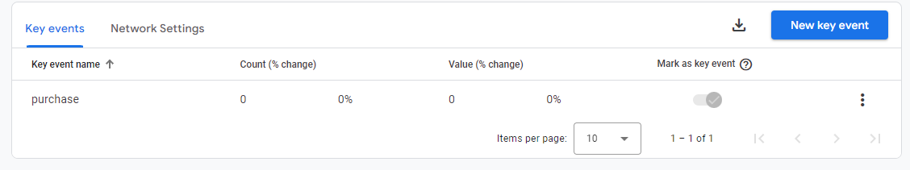
Conclusion: We would recommend considering the change of the number of key events to reflect each bottleneck of your conversion vortex for the further proper analysis.

2.10.3 Custom definitions
A custom dimension or metric in Google Analytics enables you to analyze and advertise using the custom data you've gathered from your website or app. A custom dimension or metric goes beyond the standard data automatically collected and surfaced by Google Analytics, allowing for more detailed and relevant analysis. According to the 1.2, there are no data from the GTM, assuming that there can be no Custom dimensions.

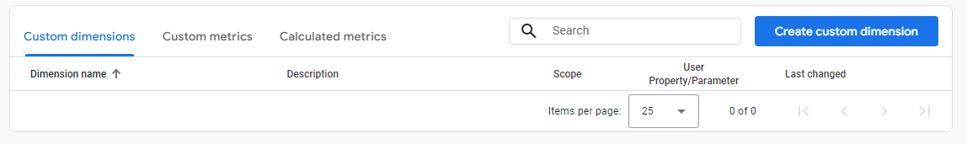
Conclusion: no custom dimensions were detected. Adjustment of GTM and Tags creation is strongly recommended.

3. Checking the sending of events
According to the previously mentioned 1.2, no tags were created for GTM. Therefore, according to the information provided in 2.2.1, only enhanced measure events that are automatically collected are sent.
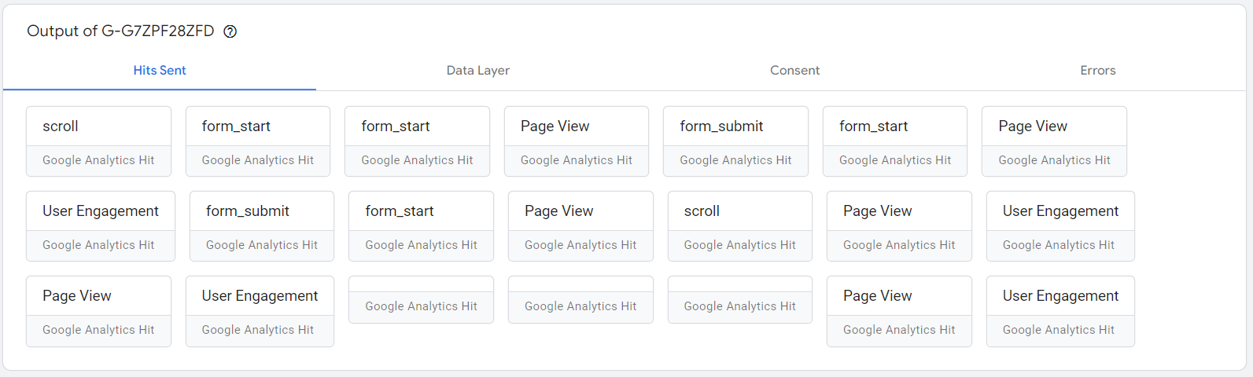

5. General Recommendations

1. Develop basic events tracking with GTM: view item, add to cart, begin checkout, purchase. Those events are strongly recommended for the creation of an effective attribution model.

2. Connect Google Analytics and Google Ads in case of its future application. This will allow you to relate your cpc campaigns with the events data. In conjunction with the application of Google BigQuery, this will provide sufficient data for analysis.

2. Connect Google Analytics and Google BigQuery. This would be beneficial for analytic purposes, allowing data filtration, purification, aggregation and integration into the visualization tools for effective reporting.

3. Adjust events transfer from GTM after part 1 of recommendations is fulfilled.

4. Check events with Measurement Protocol regarding possible sending mistakes.

6. Consider checking the UX (user experience) of websites.

